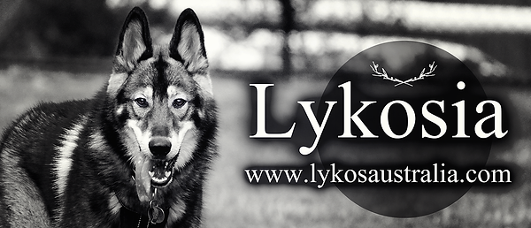
PUPPY APPLICATION FORM
1. Personal Details
First name:
Last name:
Age:
Address:
Mobile:
Email:

Q: Have you applied for puppies from any other breeder recently?

2. Please detail your living situation (ie. Live by yourself, with a partner, with parents, with friends etc.)

3. Do you own your own home, or do you rent? (Note: if you rent, you may be asked to provide a letter from your landlord or leasing agent that states you are allowed a dog on the property)

4. Please list your preference for a puppy (male, female, either male or female, colour preference, any temperament traits you feel would suit your lifestyle)

5. Are you seeking a pet only/companion dog (desexed or to be desexed) or seeking a potential breeding dog?

6. Have you read more on our website about our Puppy Sale Agreements? What do you understand about them?

7. Please describe any previous and current experience with dogs, including any advanced training or competitive sports completed with them.

8. If you have any other pets, please list the type of pets and their ages and whether they are desexed. If you own another dog, please describe their temperament with people and dogs and their level of training. (Feel free to attach/paste photos of them)

9. Where will your dog be housed at your property? (Outdoors only, indoors and outdoors, crated inside, inside at night, free roaming access via doggy door, dog run/kennel/enclosure, other)

10. Do you have a fenced yard and good gates? What is the setup of your property? (Type of fencing, height and gates, please state whether they are secure/locked). Please attach or paste photos of your property, as well as showing how secure the fencing is.

11. How many hours a day will your puppy/dog be left at home alone and under what circumstances?

12. If you have children, what are their ages and their experience with dogs?

13. Please explain what you consider to be “responsible pet ownership”

14. Please explain how you intend to train your puppy and your past experience in training dogs. Will you be attending dog training lessons? Do you have a local trainer or canine/obedience club? How much time do you think is required for training and how often?

15. Please describe what you understand about the requirements of canine health and nutrition (ie. feeding, dental, vaccinations, worming)

16. What are some common signs and symptoms that your puppy/dog is unwell?

17. Please describe what you understand about the Lykos breed (ie. Their temperament and requirements)

18. What is your current employment status and how often do you work?

19. Do you have a particular preference of a puppy from a current litter? If so, please let us know which one and what you like about him/her.

20. Do you have any questions you would like to ask us?

Thank you for your time in completing this application. We endeavour to get back to you at the earliest possible convenience. Please do not feel disheartened if you miss out on a puppy. You are more than welcome to apply again for another pup from another litter. As the Lykos breed is still in development there are a lot of people interested in having one of their own and there are only a few Lykos breeders which means only a limited number of pups become available. Should you be unsuccessful, our advice is to wait and try again when another litter becomes available from one of the programs reputable breeders.

Please email completed form back to:
lykosaust@gmail.com

